Products Installed:
- Speechline
- Control Cockpit
- TCC2 with TruVoicelift
- MobileConnect

Others involved include Hewshott International (AV Consultant) as well as their integrators who are Strive AV and GVAV.

University of Greenwich evolves to Hyflex learning with AVer Auto Tracking Cameras
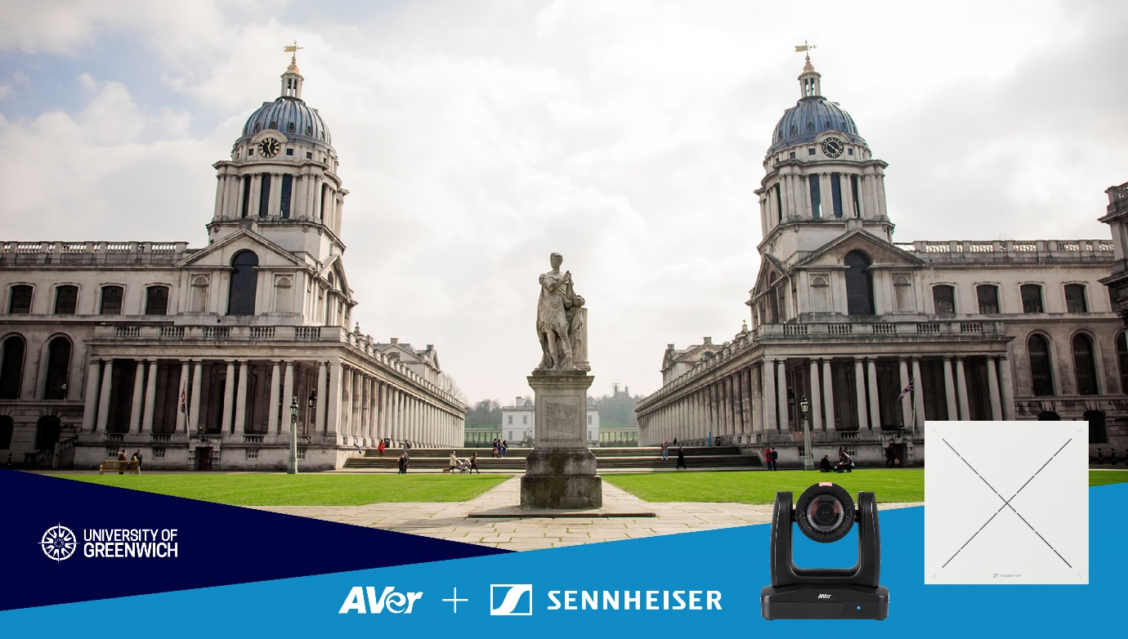
AVer Europe case study
The University of Greenwich has been providing higher education for over 125 years.
The University of Greenwich is a public, research university with four faculties: Liberal Arts & Sciences; Business School; Education, Health and Human Sciences; and Engineering & Science. It is part of the University Alliance group and is gold rated in the Teaching Excellence Framework.
The university operates across three campuses: Greenwich and Avery Hill in London and Medway in Kent. Its renowned research has been globally received and endorsed by nine Times Higher Education Awards and five Queen’s Anniversary Prizes for Higher & Further Education.
The university offers over 200 courses to prospective graduates, attracting a high calibre of UK and international students.
Uncertainty from COVID-19 lockdown
During 2020, the university, like the rest of the UK, had been subject to COVID-19 lockdown laws. Teaching staff and students had switched from classroom teaching to remote learning using the Microsoft Teams (MS Teams) software platform to ensure courses could continue.
At the end of 2020, UK restrictions were starting to lift. This meant that classroom lessons could resume from January 2021. However, there was still uncertainty around the lifting of restrictions. In the event of a positive COVID test, staff and students would have to self-isolate and international students, who make up a considerable proportion of the students, were unable to attend classes in person due to international travel restrictions.
This presented Mark Affection, Head of Digital AV Solutions at the university and his team with a unique AV challenge: ensuring that a quality learning experience was provided by the university to both in-class and remote participants. To ensure that no student was left behind due to physical restrictions, a new hybrid system of underpinning AV technology was required.
Lessons from lockdown
During lockdown, the MS Teams software functionality proved to be invaluable. Online video sessions enabled course continuity and teaching staff made the most of MS Teams’ inbuilt messaging and screen sharing features to create the most interactive experience possible. Nonetheless, a survey about remote teaching from the university to staff and students revealed experiences of fatigue, frustration and loss of concentration during the longer discussion and debate sessions, especially when either the lecturer or student was not able to use video facilities.
“Not having a camera creates a disconnect,” explained Mark. “When having two-way teaching, it is important that participants are seen. Video conferencing is complex. Some students may switch off if they feel uninvolved; others can struggle to pay attention and sadly fall behind. We had to enable our teaching colleagues to deliver an enriching learning experience.”
It became apparent that a new AV solution that could provide a flexible learning environment for both in-class and online remote participants was required to ensure an engaging, immersive experience. The solution needed to be adaptable to change in the event of future restrictions on attendance at the university’s three campuses.
What was needed?
Prior to the start of the January 2021 term, Mark worked with colleagues across the university to assess the capabilities of the software, hardware and estate facilities where teaching is delivered.
Firstly, the features of MS Teams were explored in greater detail. Teaching staff had shown great initiative during lockdown and there was now a good degree of familiarity and acceptance of the platform.
The team took this innovation and feedback from the survey to map out how the classrooms could be modified to integrate with MS Teams and other camera and microphone technology.
Hello Hyflex!
The entire Old Royal Naval College campus, where the university’s Greenwich campus is located, is part of a UNESCO World Heritage Site. Furthermore, the historic Queen Anne Building on the Greenwich campus is a listed building; and therefore, before any work could be considered, a dialogue with Historic England would be necessary. Ensuring compliant building methods were adhered to, different concepts were set up in a room to try to find a standard teaching configuration that could be used to teach students in situ, remotely or via blend of both. The university coined this solution as “Hyflex.”
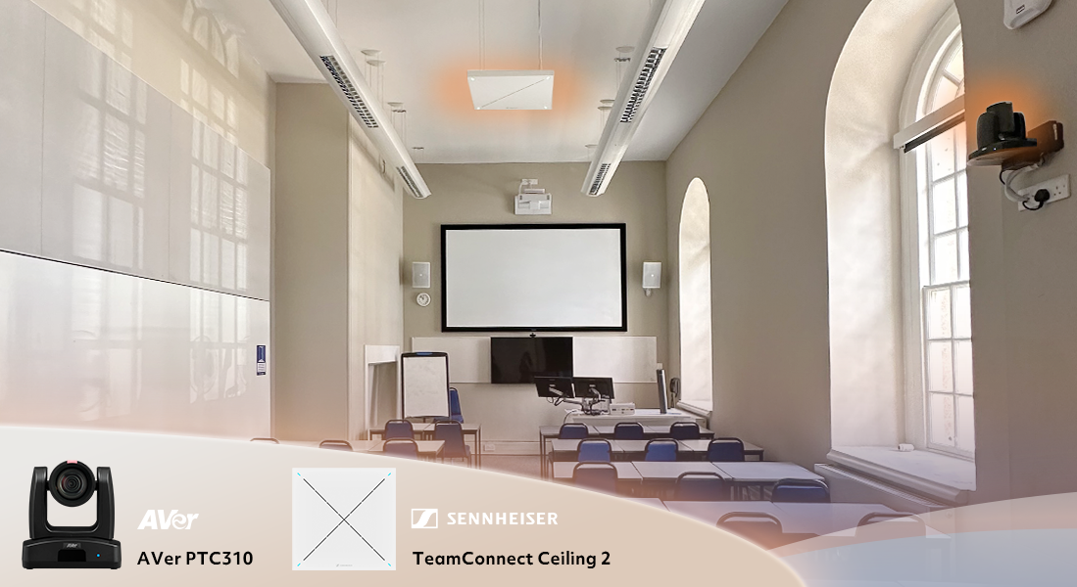
The configuration needed a lecture podium, computers, visualisers, and a white board; all things typically found in a classroom. For Hyflex, a key requirement identified during lockdown was the need for a second monitor for the lecturer. This allows them to show their presentation on the left and participants on the right. This adaptation was developed because, during remote delivery, teaching staff reported struggling to see when a student raised their hand to ask or type a question. The second screen needed to be replicated on a large display monitor on the wall facing the podium to ensure the remote students are visually present to both the rest of the remote audience and the speaker. They hoped that this would help foster a sense of inclusivity.
Building on that sense of inclusivity, the team investigated what benefits Auto Tracking Cameras could bring.
Evaluation of Auto Tracking Technology
“I’ve always kept an eye open on different manufacturers and by attending edtech events you get an understanding of what the different brands provide,” said Mark. “I’d previously seen AVer and mentioned their name to integration partners who said good things about them. I looked at their website and at what their customers were saying about them and decided to get in touch.”
Bally Hunjan, AVer Europe, Channel Sales Manager, discussed the requirement and sent sample products of the AVer PTC310* (Auto Tracking Camera) and PTC500** (Dual Lens Auto Tracking Camera) to help the team test different configurations and integrations with MS Teams.
Over a month, the cameras were put through their paces. The team evaluated the camera’s AI functionality in detecting, recognising and switching video between different speakers and different zones.
Bally visited the Greenwich campus and demonstrated the different tripod and wall mounting configurations, which illustrated the suitability of the cameras for the wide range of courses the university provides.
Integrated Pro AV audio and video needed
A key requirement for the cameras was the ability to integrate with other hardware. The team had identified that a fixed microphone on the lecturer’s podium wasn’t adequate for group discussion. The sound levels were mixed. A handheld microphone would be too cumbersome to pass round the audience, so the team looked to install centrally placed, ceiling mounted acoustic panel microphones.
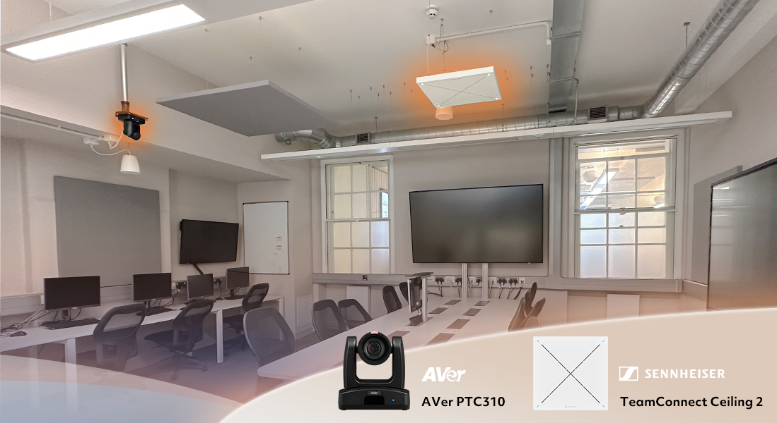
After extensive evaluation, Sennheiser’s TeamConnect Ceiling 2 (TCC 2) microphone solution emerged as the most effective option. The microphone could also be integrated with the AVer cameras using the AVer PTZ Link software bridge so that both the camera and microphone could intelligently detect and follow the active speaker.
“Given our extensive use of Sennheiser audio solutions, like the Evolution Series and SpeechLine, we were confident in the superior quality technology offered by their products for our classrooms and lecture halls,” says Mark. “Upon testing the TCC 2 solution with Sennheiser’s Inesh Patel [Business Development Manager – Business Communication], and Joe Mahoney [Customer Development & Application Engineer], who visited our facilities to set up the microphones in a classroom environment, we were thrilled with its performance. It captured voices from various positions, while allowing prioritisation. And that’s when we realised the potential of this technology and thought ‘this could really work for us!’.”
Following the successful classroom testing, the team extended the evaluation to a lecture theatre, testing the TCC 2 microphone with TruVoicelift technology. Once again, the test yielded tremendous success. “We were astonished by the performance,” Mark continues. “This reinforced our confidence in the product's suitability, both for teaching in classrooms and voice reinforcement in lecture theatres.”
Initially installing TCC 2, the team has since outfitted four smaller classrooms with the new TeamConnect Ceiling Medium ceiling microphone. Additionally, they are currently piloting Sennheiser’s innovative, scalable, app-based accessibility solution. called MobileConnect, with the aim to on-board it as part of the university’s assistive hearing technology across all three campuses.
AVer Europe evaluated
With an optimum configuration identified, AVer provided a quote to deliver camera technology for an initial 24 rooms, 4 larger lecture theatres and IT labs across the three university campuses.
Considerations for the university included the upfront cost, what level of support they would get for the hardware and software, how long the AVer warranty would be and support for the higher education AV investment lifecycle of between 3 to 5 years.
Having provided a competitive price, sharing details on the warranty, and satisfying other questions, the university completed their due diligence and opted to go ahead.
A rapid rollout across three campuses
A swift implementation of the new AV solution was delivered to the rooms across the three campuses. With over 200 courses offered by the university, there was a wide range of configurations. For instance, for teaching legal subjects, a “Moot Room” is set up exactly like a real-life courtroom. The addition of the cameras and microphones sets the scene for a much more involved method of learning.
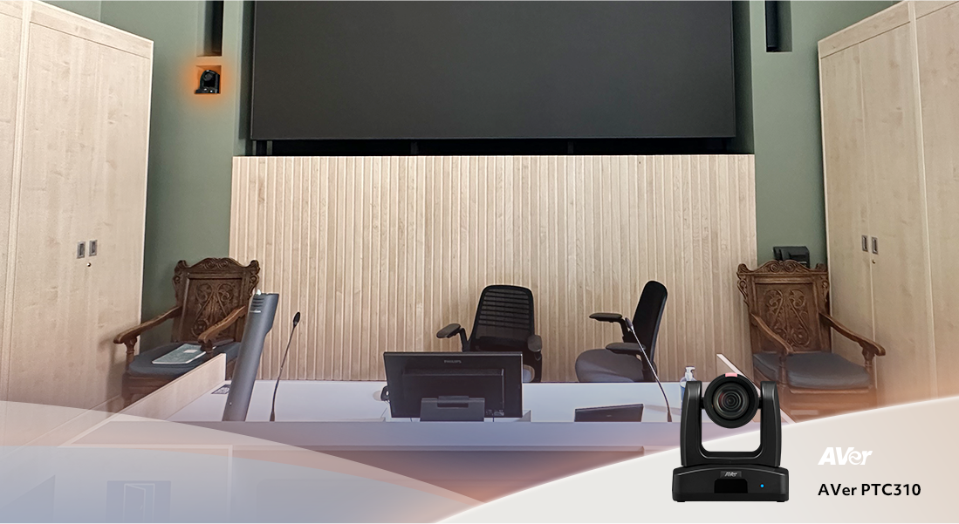
The faculty team pulled out the stops to ensure that the three campuses were ready when the university began teaching in September.
Lights, cameras, action!
Carefully monitoring usage, the team was pleasantly surprised with how frictionless the roll-out went. Due to the familiarity of MS Teams from the lockdown experience, joining sessions proved to be no problem for faculty in classrooms or for remote students.
The next step was to see how the underpinning AV technology would be received. Teaching on your own in a blended environment without an assistant could be quite a lot for a lecturer to manage. Fortunately, it became quickly apparent that the AV solution supported this activity well. The hardware configuration worked seamlessly. Tracking was switched on/off via a control system for an individual session.
The Aver PTZ Management software became very handy as a remote IT support tool for the team, particularly if a colleague had any questions about the cameras or the configuration.
Adoption and innovation
University teaching staff and all the students quickly adapted to the new experience. From a teaching perspective, new options became available. On some of the scientific and technical courses, the AV solution provided the platform for even more sophisticated deployments. For people taking part at home, the experience was more engaging and remote attendance levels and student satisfaction increased as a result.
The AV configuration achieved its objective of ensuring course continuity and improving the learning experience for all stakeholders. This was especially valuable for international students, some of whom still could not travel to the UK, but could participate in the learning discussions remotely.
Helping reduce carbon emissions from travel
The technology supports the university’s goal of hitting new zero carbon emissions by 2030. Mark noted that university staff had reduced the amount of travel between the three campuses for meetings since the implementation.
Mark said “It’s become De facto for our staff to hold meetings online now. The auto tracking doesn’t hinder or stifle conversation.”
He added:
“The AVer camera technology has been massively successful. We are very impressed with how it’s worked so far. Clarity and optics have been well received.”
Looking backwards and forwards
Mark said “Out of a dreadful situation (COVID-19), there have been positive and interesting developments in the way that people engage with these technologies, which I don’t see us reverting back from. Necessity forced this change and people have embraced these technologies and become accustomed to them.”
Looking to the future Mark said:
“Feedback from non-remote rooms is that the Hyflex configuration is needed as the new normal. ‘We want the cameras; we want the microphones and dual screen’ they say. We aim to continue to work this way.”

To know more about AVer Pro AV Cameras, please visit https://presentation.aver.com/lines/pro-av.
To know more about Sennheiser TeamConnect Family, please visit https://www.sennheiser.com/en-us/product-families/teamconnect-family.
To know more about AVer-Sennheiser Solutions, please visit https://www.aver.com/press-release/AVer-Sennheiser-Partnership.

*AVer PTC310UV2/TR315 is an upgraded model of the PTC310.
**AVer PTC500+ is an upgraded model of the PTC500.

About AVer Information Inc.
Founded in 2008, AVer is an award-winning provider of education technology and video collaboration camera solutions that improve productivity and enrich learning. From accelerating learning in the classroom to increasing competitive advantage for businesses, AVer solutions leverage the power of technology to help people connect with one another to achieve great things. AVer's product portfolio includes professional-grade artificial intelligence-enabled auto-tracking cameras, Zoom and Microsoft Teams Certified enterprise-grade USB cameras, document cameras, and mobile device charging solutions. AVer strives to provide industry-leading service and support that exceeds customer expectations. AVer is deeply committed to the community and the environment, and it employs stringent green processes. Learn more at aver.com.
About the Sennheiser Group

Building the future of audio and creating unique sound experiences for our customers - this is the aspiration that unites the employees of the Sennheiser Group worldwide. The independent family-owned company Sennheiser was founded in 1945. Today, it is managed in the third generation by Dr. Andreas Sennheiser and Daniel Sennheiser and is one of the leading manufacturers in the field of professional audio technology.

sennheiser.com | neumann.com | dear-reality.com | merging.com

